# **Developer Manual: St. Mary’s Sacrament Member Management System**

**Table of Contents**

**Accessing the System 2**

**Search Member Functionality 2**

**Add Member Info 2**

**Update Member Info 3**

**Delete Member Info 3**

**Setting Up User Access Authorization 3**

**Sacrament Records 4**

**Member Registration 4**

**Member Profile 4**

**Data Entry Alerts 5**

**To-Be Concept Diagram: 5**

**Entity Relationship Diagram: 6**

**Installation/Setup Steps: 6**

**Sandbox and Production Environment: 6**

**Go-live Steps: 7**

**Configuration Standards + I/O Standards: 8**

**How to acquire password: 9**

**How to edit or update the code or software configuration: 9**

# Accessing the System

1. Log into the database via www.airtable.com using the provided login credentials.

2. Once logged in, navigate to the "St. Mary’s Sacrament Member Management" table, which houses the "Members" table.

# Search Member Functionality

1. Navigate to the search & filter extension located on the right side of the screen under extensions.

2. To add new search fields, select the symbol that looks like a setting symbol or wheel.

3. Under the specific fields section, you will find dropdowns where it says “Pick a Field”.

4. Choose the appropriate field you would like to add to search on.

5. In order to remove a field, you can press the delete or x button on the right side of the field.

6. Save any changes by pressing Done on the bottom right corner.

# Add Member Info

Add member functionality is integrated into the system, refer to the admin manual guide for further instructions, however in order to address adding column functionality to capture more information for the members, the instructions are as follows:

1. Navigate to the right end of the database and find an empty column.

2. Press the “+” sign that is present at the end of the column

3. This will reveal fields to add new information over the column being added such as “Field Name” and “Field Type”.

4. Click out of the tab to save the information and generate a new column.

# Update Member Info

Update member functionality is integrated into the system, refer to the admin manual guide for further instructions, however in order to address changing column functionality to capture more information for the members, the instructions are as follows:

1. Right click on the database header of the column name.

2. Click on edit field

3. This will reveal fields to change field information of the column such as “Field Name” and “Field Type”.

4. Click the save button to save changes.

# Delete Member Info

Delete member functionality is integrated into the system, refer to the admin manual guide for further instructions, however in order to address changing column functionality by deleting an existing column to refine information, the instructions are as follows:

1. Right click on the database header of the column name.

2. Scroll down to the bottom to the “Delete Field” button.

3. Press the button and press “Delete Field” again as validation pops up. (Validation is present to prevent accidental deletion.

# Setting Up User Access Authorization

User Access Authorization is integrated into the system, refer to the admin manual guide for further instructions as that is the only configuring method required to fulfill the dev requirements as well.

# Sacrament Records

Sacrament Records is integrated into the system, refer to the admin manual guide for further instructions as that is the only configuring method required to fulfill the dev requirements as well.

# Member Registration

Member Registration functionality is integrated into the system, refer to the admin manual guide for further instructions, however in order to address changing field functionality by deleting an existing column to refine information, the instructions are as follows:

1. Navigate to the “Interfaces” Section of the dashboard

2. Scroll down to the forms section to see all of the forms present.

3. Press on the form that you want to edit.

4. As you click on the form, you can press into a field on the form to edit using the toggle that pops up on the right side of the screen.

5. You can edit the name, the character limit, title, visibility and max count.

6. In order to delete the field, navigate to the three dots on the top right of the toggle and press the button. It will present an option to delete the field.

7. In order to add a field, hover under the field where you want to add a new field and press the plus sign button. Click an existing field or add a new field to add data too.

8. Press the blue “publish” button on the top right corner to save changes and release to the web. If it asks who can have access choose, “Anyone on the Web” option. This will save your changes.

# Member Profile

Member Profile is integrated into the system, refer to the admin manual guide for further instructions as that is the only configuring method required to fulfill the dev requirements as well.

# Data Entry Alerts

1. Access the system using “Accessing the System” instructions present at the beginning of the manual.

2. As you log in, navigate to the “Automations” tab on the blue dashboard.

3. You will see the “Automations List” on the left hand side of the screen.

4. As you click on an automation, there will be an “on/off” toggle on the top right side of the dashboard to turn automations on or off.

5. If you click the first button on the automation screen, it will be the trigger condition. On the right side a “trigger details” window will appear. You can use the drop downs to change the “trigger type”, “table”, and “form” that the trigger corresponds to.

6. If you click the second button on the automation screen, it will be the actions condition. On the right side a “actions details” window will appear. You can use the drop downs to change the “action type” and type out a new “description”, new email for “To” (who the email goes to), “subject” of the email, “message” of the email, and add any attachments.

7. All actions are automatically saved. Make sure to turn the toggle “on” for the automation to work.

# To-Be Concept Diagram:

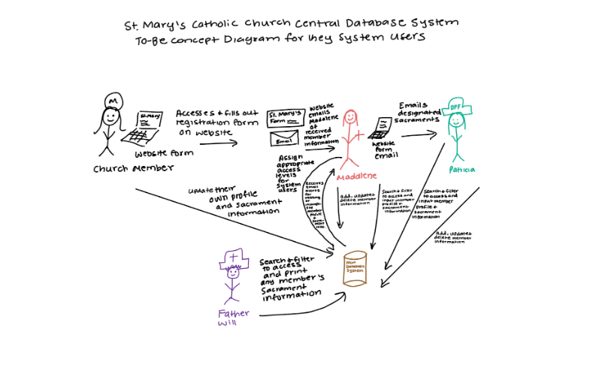

# Entity Relationship Diagram:

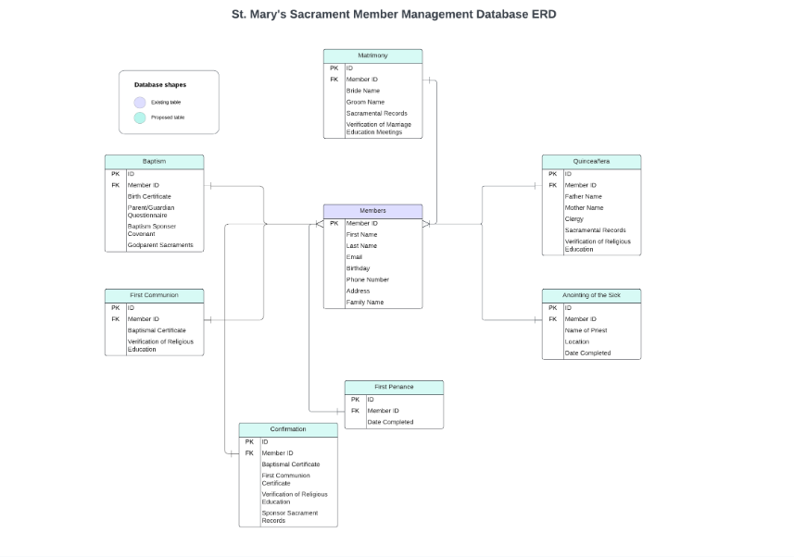

# Installation/Setup Steps:

1. Go to [**https://airtable.com/login**](https://airtable.com/login?_gl=1*3mh1lq*_ga*MTg5Nzc5MjYxNy4xNzExNjY2NjA4*_ga_VJY8J9RFZM*MTcxMzIxNTI0NC4xMC4xLjE3MTMyMTUzMDIuMi4wLjA.)
2. Create a new account by clicking ‘Sign up now’ or enter email address if you already have an account - will have to login using
3. Enter your password and sign in
4. Will be directed to home page dashboard
5. Click on the “St. Mary’s Sacrament Member Management” Database to enter into the database and view records

# Sandbox and Production Environment:

In our production environment, whenever a user is in the system and adds, updates, or deletes a new member or assigns user access authorization. Airtable updates in real time so it gives the user the ability to click out of making changes after completing these tasks. For certain parts, such as updating columns it is needed to press the "Save" button to ensure the changes are made and saved to the system. Majority of the work that is edited is saved in real-time so only a reliable internet connection is needed to save the data. There is no need to publish any data as the creation of the database ensures that it is published and available to those who are granted access to it.

# Go-live Steps:

1. Pre-Deployment Preparation:

- Owner: Project Manager

- Verify that all user stories for the current sprint are completed and tested.

- Ensure that all necessary documentation, including manuals and video tutorials, are finalized and ready for distribution.

- Coordinate with the client to confirm weekly meeting time to schedule deployment and finish the final training.

- Backup the current database to prevent data loss during deployment

Backup steps:

1. Go to [**https://airtable.com/login**](https://airtable.com/login?_gl=1*3mh1lq*_ga*MTg5Nzc5MjYxNy4xNzExNjY2NjA4*_ga_VJY8J9RFZM*MTcxMzIxNTI0NC4xMC4xLjE3MTMyMTUzMDIuMi4wLjA.)
2. Login with the appropriate credentials
3. Navigate to the “St. Mary’s Sacrament Member Management” Database
4. Click into the database
5. Press the word “Grid View” on the top left header of each table view
6. Download each view as a CSV and save as backup data for the database

2. Deployment Day:

- Owner: Project Manager, Developer

- Communicate the deployment schedule and any downtime to the client and internal stakeholders.

- Disable access to the system for all users except administrators to prevent data conflicts during deployment.

- Run deployment scripts or migrations to update the database schema if necessary.

- Enable access to the system for administrators and conduct final checks to ensure the system is operational.

- Notify the client and internal stakeholders once the deployment is completed successfully.

3. Post-Deployment Tasks:

- Owner: Project Manager, Developer

- Monitor system performance and user feedback to identify any issues or bugs that may arise post-deployment.

- Address any reported issues promptly and deploy patches as needed.

- Conduct user training sessions to familiarize administrators with any new features or changes introduced in the latest deployment.

- Provide ongoing support to users and address any questions or concerns they may have regarding the deployed system.

- Ask for post-deployment client feedback and discuss any lessons learned for future deployments.

# Configuration Standards + I/O Standards:

Configuration Standards:

1. Database Configuration:

* Ensure that the database schema follows normalized design principles to minimize data redundancy and improve data integrity.
* Define primary and foreign key constraints to establish relationships between tables.
* Set up indexes on frequently queried columns to optimize database performance

Styling Standards:

1. User Interface Design:

* Follow design principles to ensure that the application is accessible and user-friendly across various devices and screen sizes.
* Use a consistent color scheme, typography, and layout throughout the application to maintain visual coherence.
* Implement intuitive navigation and clear hierarchy to enhance user experience and facilitate task completion.
* Adhere to St. Mary’s branding guidelines regarding logos, colors, and typography to maintain brand consistency.

Coding Standards:

1. Language and Framework:

* Due to the use of a packaged solution, we do not have coding standards as they are not utilized.
* Use meaningful variable and function names to improve code readability and maintainability.
* Implement robust error handling mechanisms to gracefully handle exceptions and prevent application crashes.
* Integrate logging functionality to record critical events and debug information for troubleshooting purposes.

1. I/O standards (data validation)

While our system does not encompass configuration standards or outputs for deployment, it does incorporate input standards vital for the efficient management of sacrament member data. When administrators aim to add or update member records, they encounter essential input criteria, or required fields, ensuring accurate data entry into the system for the main “Members” table which links to the rest of the tables that connect members to their completed sacraments:

- Member First Name (string)

- Member Last Name (string)

- Date of Birth (date)

- Family Name (string)

- Address (string)

- Phone Number (phone)

- Sacrament (dropdown)

These input standards facilitate consistent data capture within our system, empowering administrators to seamlessly manage sacrament member information. By adhering to these standards and guidelines, the St. Mary’s Sacrament Member Management System will benefit from improved maintainability, scalability, and security throughout its development lifecycle.

# How to acquire password:

To view the password and login information for the “St. Mary’s Sacrament Member Management” Database, please access this Login [Document](https://docs.google.com/document/d/1TIC8P4zQrcwiT5TyAd6UN1G57Xbadvo5uNiaVy0eczM/edit?usp=sharing) located in our compiled Google Drive.

# How to edit or update the code or software configuration:

**Table Creation and Linking**

1. Creating Tables:

- Log in to your Airtable account and open the workspace where you want to create the tables.

- Click on the "+" button or "Add a base" to create a new base if you haven't already.

- Once inside the base, click on the "Add a table" button to create a new table.

- Name your table based on the type of data it will store. For example, if it's for storing member information, you can name it "Members."

- After naming the table, you'll be prompted to add fields. Click on the "Add field" button to add different types of fields such as Text, Number, Date, Attachment, etc.

- Customize the fields based on the information you want to store. For example, for the "Members" table, you might include fields like "Name," "Email," "Phone Number," etc.

- Continue adding fields until you've defined all the necessary attributes for your table.

2. Linking Tables:

- Once you've created the necessary tables, you can establish relationships between them by linking records.

- Identify the fields in each table that you want to link together. For example, if you have a "Members" table and a "Sacraments" table, you might want to link them based on the member's ID.

- In the "Members" table, create a field to store unique identifiers for each member, such as "Member ID." Ensure that this field is set as the primary field.

- In the "Sacraments" table, create a field to link to the "Member ID" field in the "Members" table. This field should be of the "Link to another record" type.

- Click on the field in the "Sacraments" table that you want to link and select "Link to another record" as the field type.

- Choose the "Members" table from the dropdown menu and select the "Member ID" field as the field to link to.

- Now, when you add records to the "Sacraments" table, you can link them to specific members by selecting the corresponding member's ID.

3. Using Linked Records:

- Once tables are linked, you can easily access related records from either table.

- In the "Sacraments" table, for example, you can click on a linked record in the "Member ID" field to view details about that member in the "Members" table.

- Similarly, in the "Members" table, you can view all linked sacraments for a member by clicking on the linked records in the appropriate field.

**Form Creation**

Member Registration Form:

1. Accessing Airtable Forms:

- Open your Airtable base and navigate to the table where you want to collect member registration information, such as the "Members" table.

- Click on the "Share" button located at the top right corner of the base.

- In the dropdown menu, select "Form" to create a new form linked to the table.

2. Designing the Form:

- In the form editor, you can customize the form fields to collect relevant information from members.

- Click on "Add a question" to add fields to the form. Choose from various field types such as "Short text," "Long text," "Email," "Phone number," etc.

- Add fields such as "Name," "Email," "Phone number," "Address," and any other necessary information for member registration.

- Customize the form layout by rearranging fields, adding headers, or instructions to guide users.

3. Form Settings:

- Customize the form settings by clicking on the "Settings" tab in the form editor.

- Edit the form title, description, and confirmation message to provide clear instructions to users.

- Set up notifications to receive an email whenever a new member registration form is submitted.

4. Linking Form to Table:

- Once you've designed the form, ensure that it's linked to the appropriate table in your Airtable base.

- Confirm that each form field corresponds to a field in your "Members" table to ensure seamless data integration.

5. Sharing the Form:

- After setting up the form, click on the "Share form" button to generate a shareable link.

- Copy the link and distribute it to members through email, social media, or embed it on your website for easy access.

Sacrament Registration Form:

1. Accessing Airtable Forms:

- Follow the same steps outlined above to create a new form linked to the table where you want to collect sacrament registration information, such as the "Sacraments" table.

2. Designing the Form:

- Customize the form fields to collect relevant information from members registering for sacraments.

- Add fields such as "Member ID" (linked to the "Members" table), "Sacrament Type," "Date of Sacrament," "Location," and any other necessary information.

3. Form Settings:

- Customize the form title, description, confirmation message, and notification settings as needed.

4. Linking Form to Table:

- Ensure that each form field corresponds to a field in your "Sacraments" table to facilitate data integration and record linkage.

5. Sharing the Form:

- Generate a shareable link for the sacrament registration form and distribute it to members for completion.

**Creating Automations**

Emailing Members Their Member ID:

1. Accessing Automations:

- Navigate to the "Automations" tab located at the top of your Airtable base.

2. Creating the Automation:

- Click on the "+ New Automation" button to create a new automation.

- Choose the trigger for the automation. In this case, select "When a new record is created" as the trigger.

- Select the table where member registrations are recorded, such as the "Members" table.

3. Defining the Conditions:

- Set up any conditions if necessary. For example, you may want to specify that the automation triggers only when certain fields are filled out, such as the member's email address.

- If no conditions are needed, proceed to the next step.

4. Setting Up the Action:

- Choose the action for the automation. Select "Send an email" as the action.

- Configure the email settings by entering the recipient's email address, subject, and message.

- Include a placeholder for the member's ID field to dynamically populate the email with the member's unique ID.

- Ensure that the email contains clear instructions for members on how to use their ID for future sacrament registrations.

5. Activating the Automation:

- Review the automation settings to ensure everything is configured correctly.

- Activate the automation to start sending emails to members automatically whenever a new record is created in the "Members" table.

Notifying Madalene of New Entries:

1. Accessing Automations:

- Navigate to the "Automations" tab in your Airtable base.

2. Creating the Automation:

- Click on the "+ New Automation" button to create a new automation.

- Choose the trigger for the automation. Select "When a new record is created" as the trigger.

- Select the table where new entries are recorded, such as the "Members" or "Sacraments" table.

3. Defining the Conditions:

- Set up any conditions if necessary, such as specific fields that trigger the notification.

- If no conditions are needed, proceed to the next step.

4. Setting Up the Action:

- Choose the action for the automation. Select "Send an email" as the action.

- Configure the email settings by entering Madalene's email address as the recipient.

- Customize the email subject and message to notify Madalene of the new entry.

- Include any relevant information in the email body, such as the member's name or sacrament type.

5. Activating the Automation:

- Review the automation settings to ensure accuracy.

- Activate the automation to start sending email notifications to Madalene automatically whenever a new record is created in the specified table.